- To Record the Sermon
  - Record the sermon with the recorder in the sound console right side
  - After recording the sermon, eject the micro-SD Card
  - Insert the card in the SD adapter
  - Insert the SD card in the rear, upper right side of the Mac mini
  - Copy the file to Users -> mediaworkstation -> Documents -> CUMC Sermon Recordings (located on the sidebar of the Finder window)
  - Rename the file to the current date and speaker i.e., 20131229-Sermon-Paul_Kim.mp3
  - Eject the SD card, remove micro-card and return it to the reorder
- To Copy the File to the FTP site
  - Open Transmit by clicking on the  icon to access the CUMC FTP site.

  - Log into the website by double clicking on CUMC Website Favorite
  - 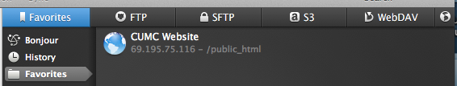
  - Go to ‘Public HTML’ -> videos -> audio
  - Drag audio, i.e., 20131229-Sermon-Paul_Kim.mp3 from Users -> mediaworkstation -> Documents -> CUMC Sermon Recordings -> to the FTP server Public HTML -> videos -> audio
  - The file transfer indicator in the lower right side will show progress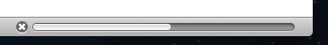
  - When the file is transferred, close FTP session with eject button

Which is located in the upper right side of the window.
  - 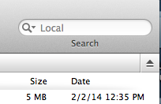
  - Quit Transmit
- To Update the Website HTML
  - Open Komodo Edit by clicking on the  on the dock.
  - Komodo should open to campbellunited.org/audio tab.
  - If the tab is not open or selected, go to the left side of the window, in the “public html” directory, open the “video” directory and double click on “index.html”
  - Scroll down to the Sunday Sermon Audio section if the cursor is not already positioned there.
  - Copy the entire first HTML entry of the Sunday Sermon Audio and move the cursor behind <ul class="nopad">,
  - hit enter and paste the copied text onto the new line. The lines should look like this:
  - Update the copied HTML entry to reflect the days sermon information. Change only the text set in red below, i.e.,
    - <li><a>ref="http://www.campbellunited.org/videos/audio/20131229-Sermon-Paul_Kim.mp3"target="_blank">
    - 12/29/2013</a> &mdash; <i>“The Road Out of Bethlehem and Back" &mdash; Rev. Paul Kim</i></li>
  - Save the change under the “File”menu.
  - Quit Komodo Edit
- Verify Change on the CUMC website
  - Open Safari by clicking on the  icon on the dock.

  - Verify the change at http://campbellunited.org/videos/index.html
  - Close Safari

